TASK 1: BASIC LINUX COMMANDS DOCUMENTATION

Objective
The objective of this task is to gain hands-on experience with basic Linux terminal commands. These commands are essential for navigating the Linux file system, managing files and directories, and retrieving system information. All commands were executed practically on Kali Linux.
1. INTRODUCTION TO LINUX TERMINAL
The Linux terminal is a command-line interface used to interact with the operating system. Instead of using a graphical interface, users can execute commands to perform tasks such as file management, system monitoring, and administration.
2. FILE & DIRECTORY NAVIGATION COMMANDS
2.1 pwd (Print Working Directory)
Command:
pwd
Explanation:
This command displays the absolute path of the current directory where the user is working.
Example Output:
/home/kali
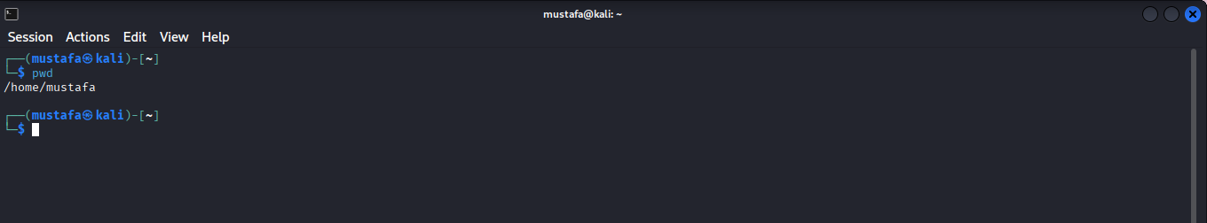
2.2 ls (List Directory Contents)
Commands:
ls
ls -l
ls -a
ls -lh
Explanation:
ls → Lists files and folders
ls -l → Shows permissions, owner, size, date
ls -a → Shows hidden files
ls -lh → Human-readable file sizes
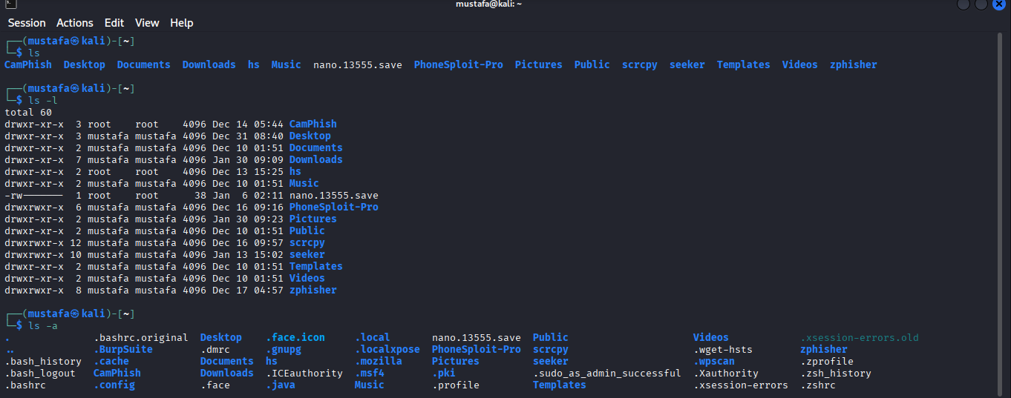
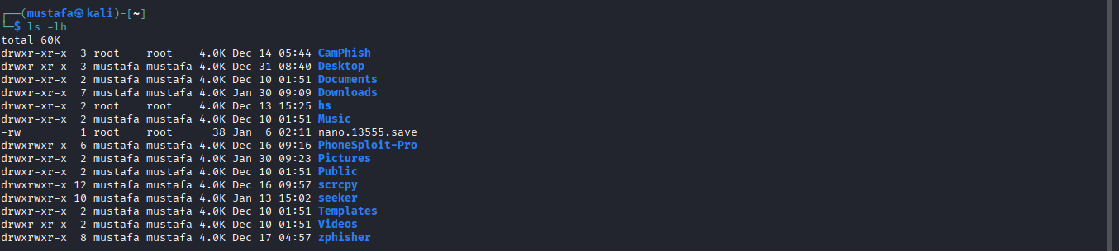
2.3 cd (Change Directory)
Commands:
cd Documents
cd ..
cd ~
cd /

Explanation:
cd Documents → Enter Documents folder
cd .. → Move one directory back
cd ~ → Go to home directory
cd / → Go to root directory
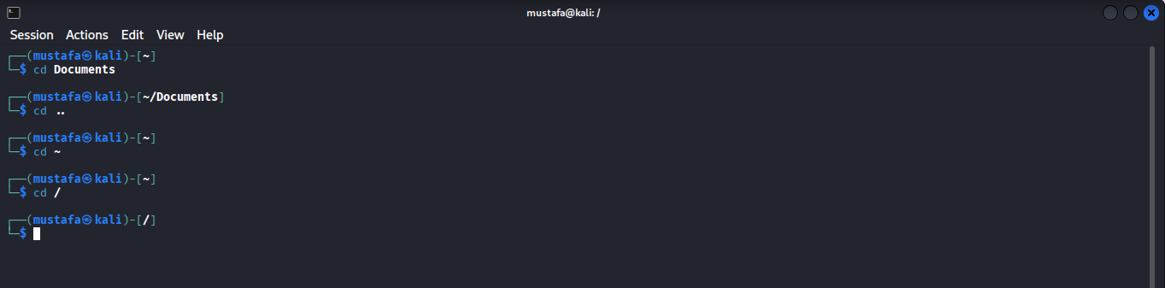
2.4 tree (Directory Structure View)
Commands:
sudo apt install tree
tree
tree Documents
Explanation:
Displays folders and subfolders in a tree structure.
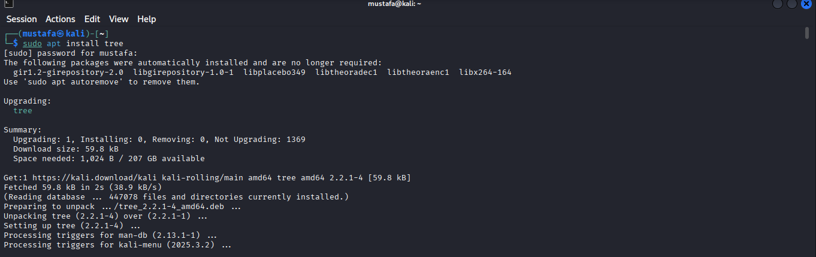
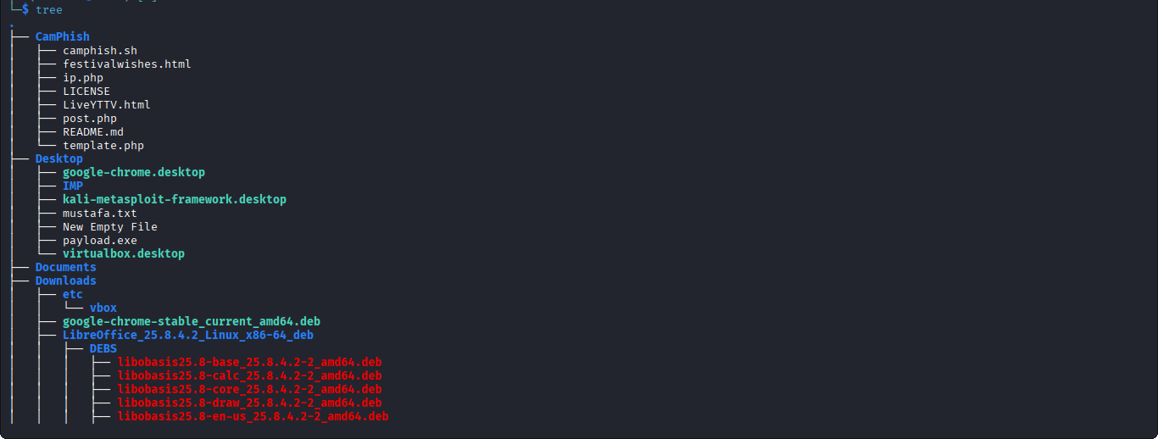
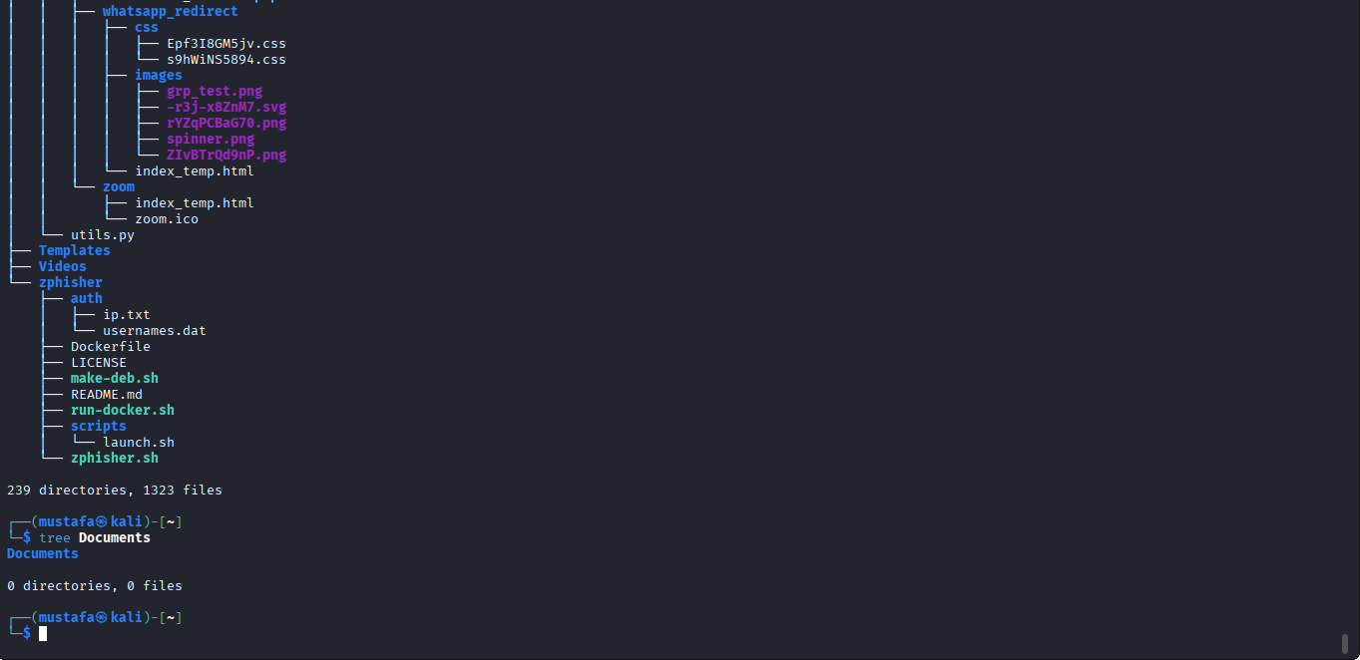
3. FILE & DIRECTORY MANAGEMENT COMMANDS
3.1
mkdir (Create Directory)
mkdir linux_practice
mkdir test1 test2 test3
Explanation:
Creates one or multiple directories.
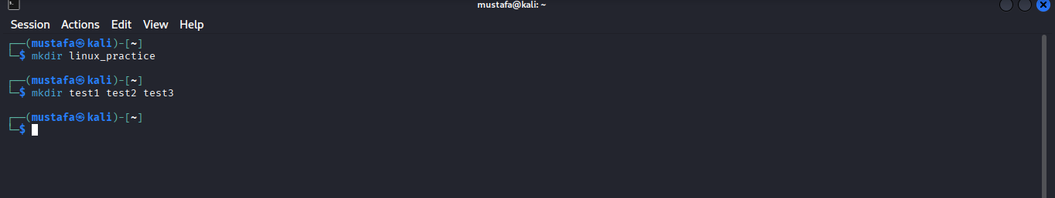
3.2
rmdir (Remove Empty Directory)
rmdir test1
3.3
touch (Create File)
touch file1.txt
touch file2.txt file3.txt
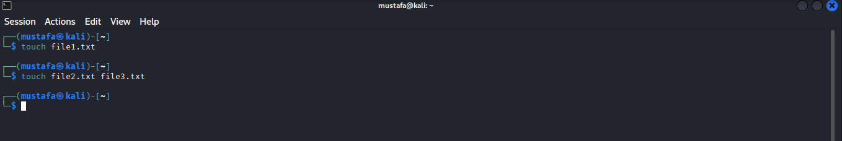
3.4
cp (Copy Files & Directories)
cp file1.txt file1_backup.txt
cp -r linux_practice backup_folder
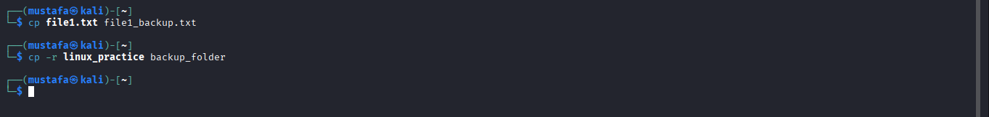
3.5
mv (Move / Rename Files)
mv file2.txt newfile.txt
mv newfile.txt linux_practice/
3.6
rm (Delete Files & Directories)
rm file3.txt
rm -r linux_practice
rm -rf foldername
Warning: rm -rf permanently deletes files.
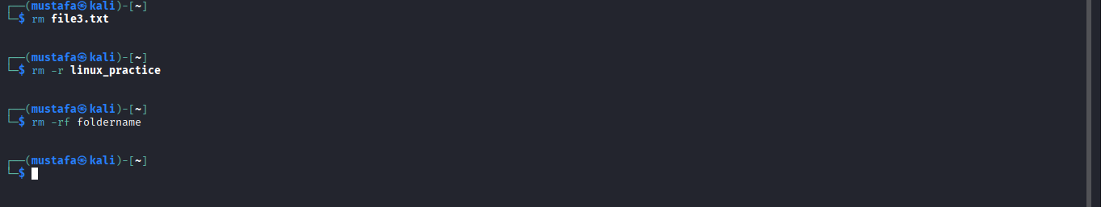
4. FILE VIEWING & CONTENT COMMANDS
4.1
cat (View File Content)
cat file1.txt
4.2
less (View Large Files)
less file1.txt
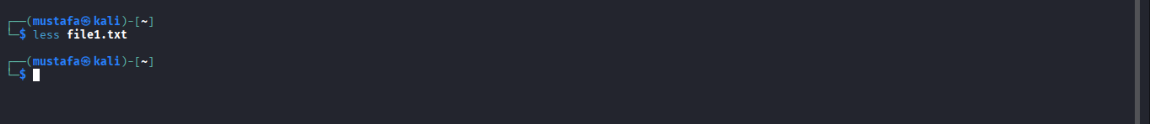

4.3
head (View First Lines)
head file1.txt
4.4
tail (View Last Lines)
tail file1.txt
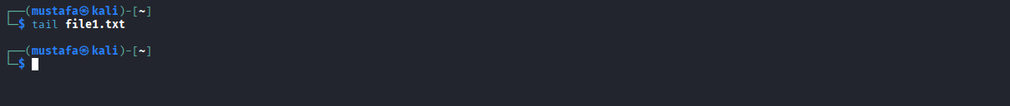
5. SYSTEM INFORMATION COMMANDS
5.1
uname (System Information)
uname
uname –a
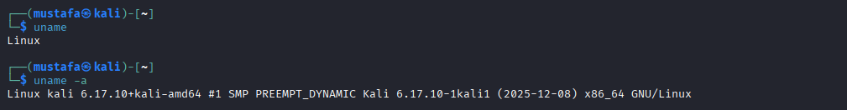

5.2
whoami (Current User)
whoami
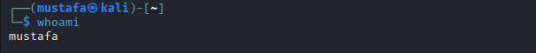
5.3
hostname (System Name)
hostname
5.4
uptime (System Running Time)
uptime
5.5
date (Current Date & Time)
date
6. DISK & MEMORY COMMANDS
6.1
df (Disk Space Usage)
df
df -h
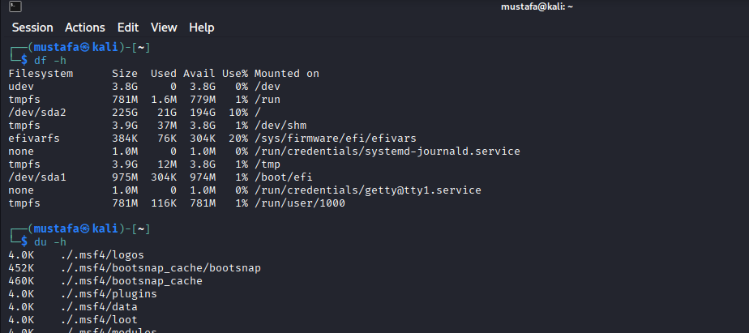
6.2
du (Directory Size)
du
du -h
du -sh Documents
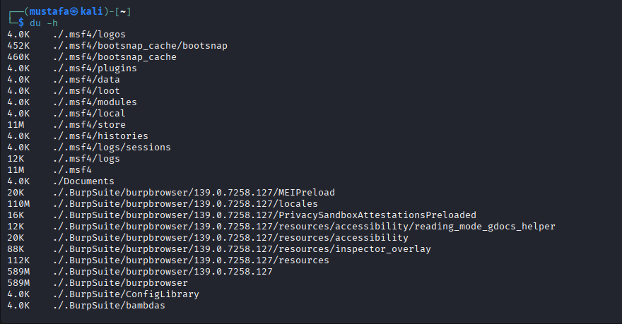

7. SEARCH & HELP COMMANDS
7.1
find (Search Files)
find /home/kali -name file1.txt
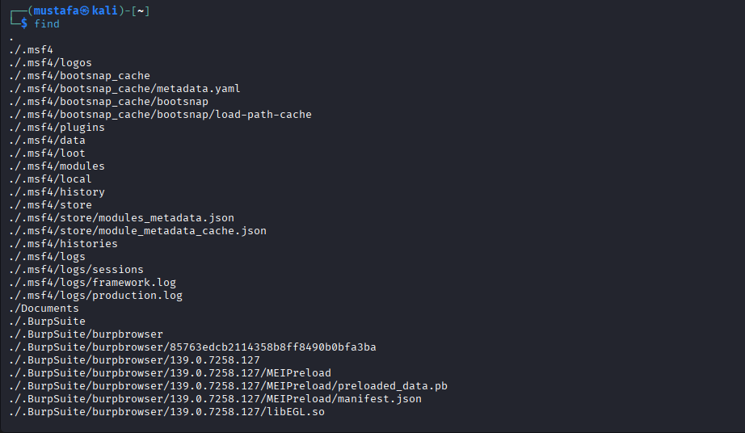
7.2
locate (Quick Search)
sudo updatedb
locate file1.txt
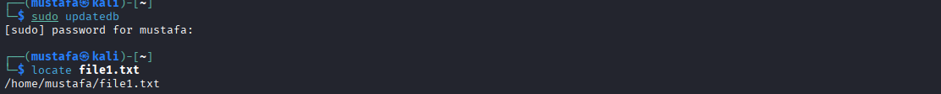
7.3
man (Manual Pages)
man ls
man cd
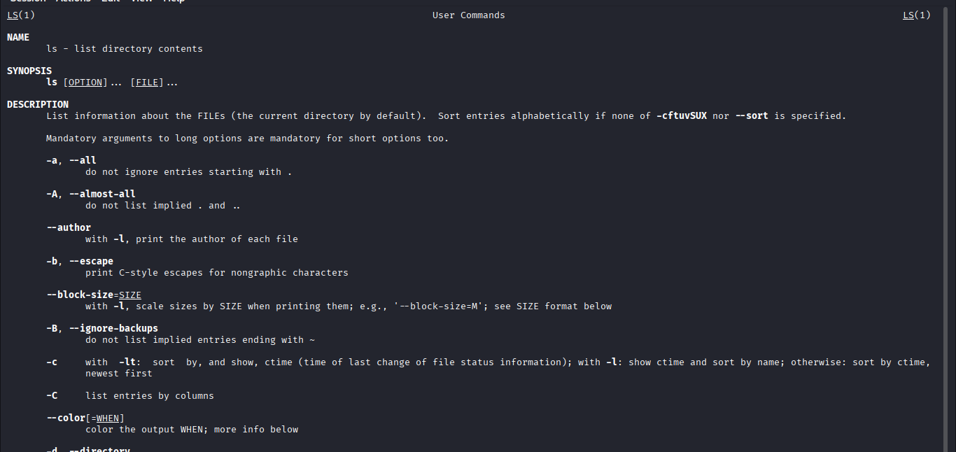
7.4
--help Option
ls --help
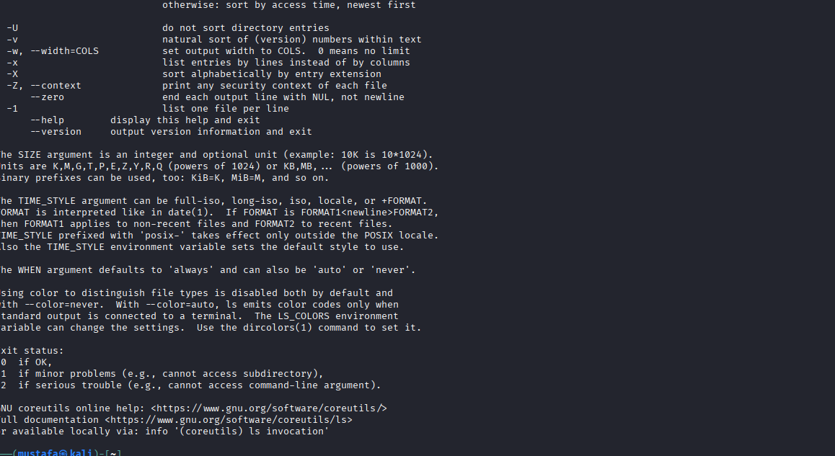
8. CLEAR & HISTORY COMMANDS
8.1 clear (Clear Terminal)
clear
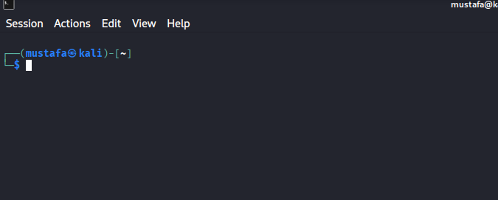
8.2 history (Command History)
history
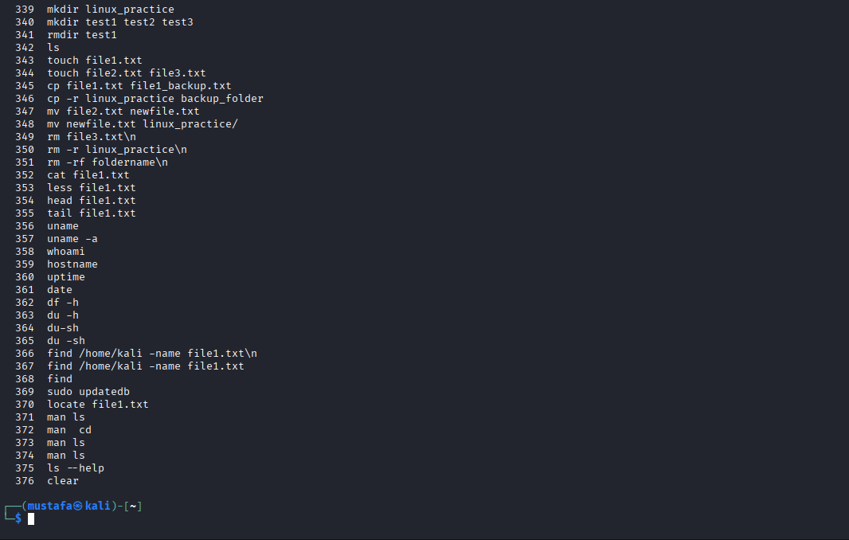
TASK 1 OUTCOME
By completing this task, I learned how to:
Navigate the Linux file system
Manage files and directories
View system and hardware information
Check disk and memory usage
Use help and manual commands effectively
These commands form the foundation of Linux system administration and cybersecurity operations.

